

FINDING MISSING PERSON USING AI

Guided by:Prof.PRADEEPTHI

Team:

1. V.PAVAN KALYAN REDDY-19BCE7040
2. M.SATYA HARSHA-19BCE7026
3. P.RADHA VISWANATH-19BCN7110
4. AVINASH KUMAR TIWARI-19BCE10153

TABLE OF CONTENTS..

* Abstract
* Introduction
* Objectives
* Methodology
* Things to be used in this Project
* Basic circuit diagram
* Results and Discussions
* Conclusion and Improvements
* References
* Appendix

# ABSTRACT

Every day more than five hundred missing person complaints are approximated to go unanswered in India. an organization called as find me group FMG that is currently active in the united states led by former field experts is committed to solve the problems that lead to such scenarios. they have introduced and made use of the missing person intelligence synthesis toolkit mist which adopts a driven-data approach to the given problem. using the same approach and slightly building upon the foundation provided by FMG we aim to tackle this problem by taking search locations on the basis of the data on hand ranks and orders the locations based on the likelihood as well as the probability allocated to the search areas based on the prior information and previous performances that are taken individually as well as a group. we compared and contrasted our approach with the current practices adopted by several organizations and entities and found that this method gives us a slight but significant advantage over many of such approaches. it is worth noteworthy that it could actually reduce the search area leading to a reduction of many square kilometres over several cases that were examined in the conducted experiments. missing individual incidents have been on a steady rise in India for the past many years. the major cause of many of these incidents never being solved the lack of timely reporting of such cases and the lack of transparency of facts and information. and because of this sadly many of those cases are never solved. the cases of human trafficking and homicides are other fields that can be tackled by this approach as many of their attributes match.

# Introduction:

The purpose of this project is to help in solving the cases and to find the victims as swiftly as possible. Hence, time is of essence here. We will be using the CNN classifier algorithm here in this regard. We have assessed our options and chosen this algorithm due to its analytical capability. Hence, the task at hand gets easier due to the reductions in cost, capital, labour and time consumed. The reasons which are noteworthy for the reduction are given below,

• The time to locate the mission person's decreases drastically.

• Reduction in direct costs.

• Reduction in indirect costs.

# Background:

The aim of the project is to focus to reduce use of the man power. Especially at the Banks or Shopping malls sectors, this can make the work either of quality or with no perfection. So, to make to a cent perfection, this can be produced which makes the work done in perfection and decreases the use of manpower

# Objective:

The main objective of this project is to find the missing people by certain procedure such as using CNN .That help the people to search missing person from any location at any time.

• The primary focus is on recognizing the face from video.

• By using several algorithm and classifier to get face edges

• Performing logical operation on previous two output.

• To track face the scalar and vector distance is used and consecutives frames are calculated.

1. **THINGS USED IN THIS PROJECT:**

* Anaconda navigator
* Tensorflow
* Keras
* Cnn algorithm
* Spyder
* Jupiter notebook

Results and Discussions:

Tested Successfully . A screenshot of the model is below

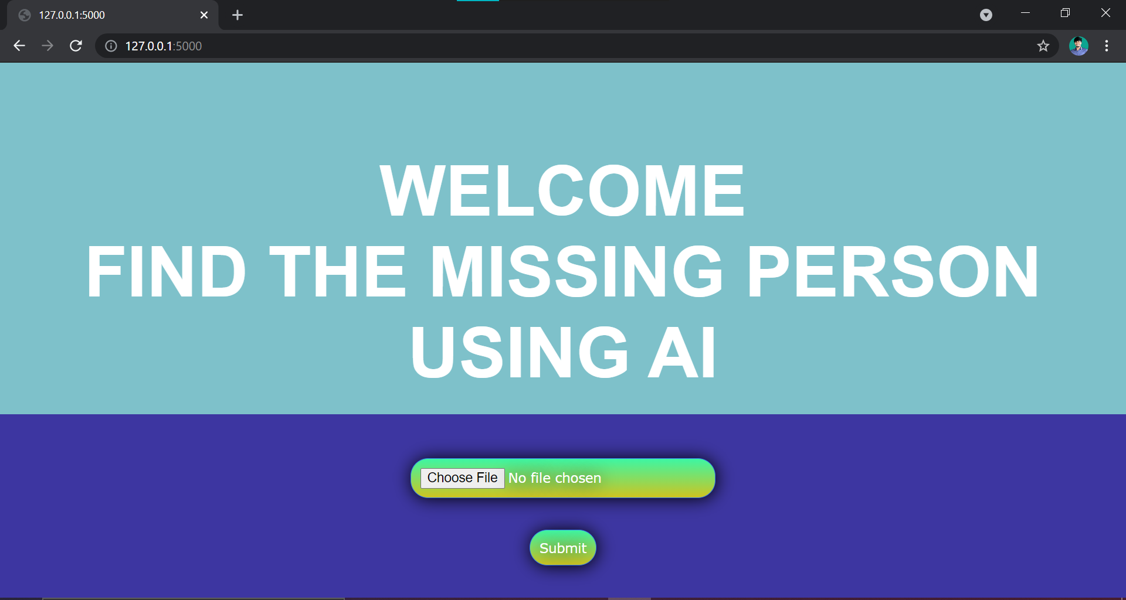

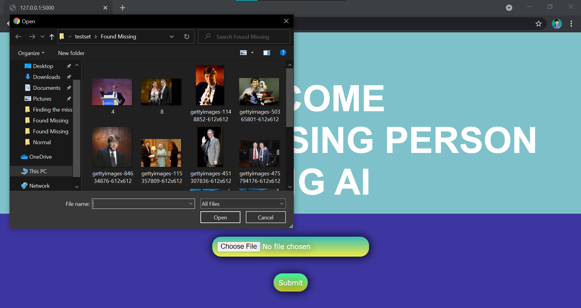

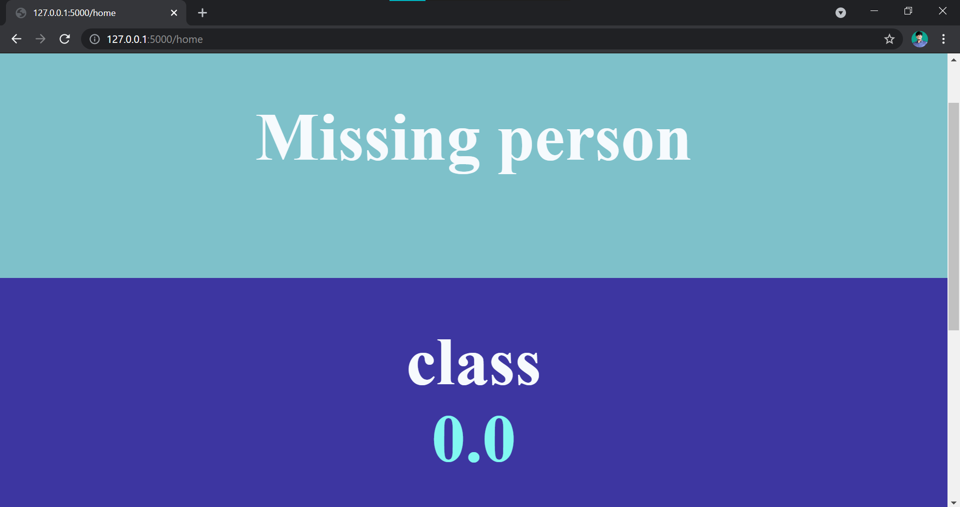

**References:**

1.L. Console, L. Portinale, and D. T. Dupre. Focussing Abductive Diagnosis. AI Communication, 2016

2. L. Console, M. L. Sapino, and D. T. Dupre. The Role of Abduction in Database View Updating. J. Intel. Inf. Syst., 2017.

3.S. do Ago Pereira and L. N. de Barros. Planning with abduction: A logical framework to explore extensions to classical planning. In Brazilian Symposium on Artificial Intelligence, pages 62- 72., 2018

4.Github references given by guide